St. Edward’s Catholic Junior School Science Curriculum 2023/24
Year groups | Advent 1 | Advent 2 | Lent 1 | Lent 2 | Pentecost 1 | Pentecost 2
3 | Rocks/ Fossils | Forces/magnets | Light | Plants  Plants Working Scientifically | Animals  Including humans | Working Scientifically
4 | Sound | Electricity | States of matter | States of matter | All Living things | Animals including humans
5 | Properties and Changes of Materials | Properties and Changes of Materials | Earth and Space | Forces and mechanisms | All Living things | Animals including humans
6 | All Living things | Light | Electricity | Animals including humans | Evolution and inheritance | Animals  (keeping healthy) Working Scientifically

Vocabulary
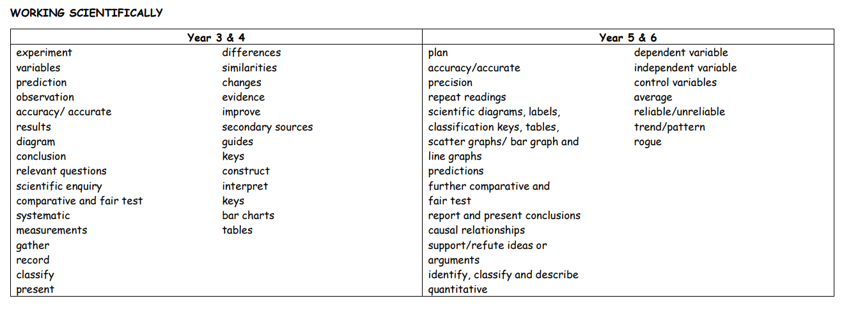

Vocabulary
Year groups | Advent 1 | Advent 2 | Lent 1 | Lent 2 | Pentecost 1 | Pentecost 2
3 | Rocks/ Fossils  Rock  Fossils  fossilisation appearance physical properties mineral elements permeable impermeable igneous sedimentary metamorphic | Forces/magnets  force contact force non-contact force magnet/magnetic attract repel magnetic poles magnetic field North South push pull motion friction surface | Light  light source see dark reflect/reflective bounce natural/artificial Sun shadow blocked solid torch lamp sunlight dangerous opaque translucent transparent | Plants  Plants Working Scientifically  flower, seed, leaf, stem/ trunk roots, petal, pollen life cycle dispersal pollination germination nutrients absorb air, light, water, soil oxygen carbon dioxide seed formation seed dispersal seed-bearing flowering non-flowering MRS GREN (movement, respiration, sensitivity, growth, reproduction, excretion, nutrition.) | Animals  Including humans  skeleton muscles tendons contract relax bones skull spine joints endoskeleton exoskeleton hydrostatic skeleton vertebrate invertebrate fish amphibians reptiles birds mammals human impact | Working Scientifically  experiment variables prediction observation accuracy/ accurate results diagram conclusion relevant questions scientific enquiry comparative and fair test systematic measurements gather record classify present differences similarities changes evidence improve secondary sources guides keys construct interpret keys bar charts tables  scatter gram/scatter graph  surface area  proportions
4 | Sound  sound wave vibrate vibration vibrating frequency air particles inner ear loud/louder insulate insulation reflect reflected sound (echo) outer ear ear drum hear hearing sound volume (amplitude) pitch faint/fainter | Electricity  electricity energy appliances electrical circuit circuit symbol cell battery wire bulb switch buzzer plug danger electrical safety sign conductors insulators open/closed circuit | States of matter  solid solidify melt freeze liquid evaporate evaporation condense condensation gas heat/heated cool/cooled water vapour water cycle changing state melting point boiling point matter particle shape volume | States of matter – The Water Cycle  processes  evaporation  condensation  Precipitation  Run off  Collection  Infiltration | All Living things  Habitat  Woodland  Savannah  Marine/Ocean  Rainforest  Desert  Environmental pollution  Food chain  Carnivore  Herbivore  Omnivore  Prey  Predator  Consumer  Producer  Energy transfer  Classification  Vertebrates  Invertebrates  Bird, mammal. Reptile, amphibian, fish | Animals including humans  digestion mouth teeth incisors canines molars tongue saliva oesophagus transports stomach acid enzymes vitamins small intestine large intestine floss brush sun producers prey predators carnivore herbivore omnivore
5 | Properties of Materials  properties hardness solubility transparency electrical conductor thermal conductor response to magnets  absorbency  flexibility  durability  strength | Changes of Materials  dissolve solution separate/separating solids/liquids/gases evaporating reversible changes dissolving mixing filtering sieving melting irreversible burning rusting magnetism insoluble | Earth and Space  Earth Sun Moon/moons planet celestial body solar system rotate day/ night orbit axis spherical heliocentric geocentric hemisphere season tilt gravity air resistance water resistance friction force surface accelerate decelerate brake mechanism pulley gear mass weight | Forces and mechanisms  gravity air resistance  thrust water resistance friction force surface accelerates decelerate brake mechanism pulley lever gear mass weight  push pull | All Living things  Classification  Vertebrates/  Invertebrates  Life cycles  Sexual reproduction  Asexual reproduction  Germination  Growth  Pollination  Fertilisation  Seed dispersal  propagation | Animals including humans  puberty life cycle gestation growth reproduces foetus baby fertilisation toddler child teenager adult old age life expectancy adolescence adulthood early adulthood middle adulthood late adulthood childhood sexual/asexual  line graph  scattergram
6 | All Living things  Vertebrates, fish, amphibian, reptiles, birds, mammals, invertebrates, insects, spiders, snails, worms, flowering and non-flowering, micro-organisms, microbe, germ, antibiotics, vaccine, decay/rot, fungi, mould, hygiene, yeast, pasteurized, bacteria | Light  light rays light source absorb travels straight reflect reflection object shadows mirrors periscope rainbow filters opaque translucent transparent bounce retina cornea optic nerve iris lens | Electricity  voltage brightness volume switches series circuit electrical safety circuit diagram switch bulb buzzer motor terminal current resistance electrons particles | Animals including humans  internal organs heart blood red/white blood cell capillaries veins arteries valve oxygen carbon dioxide lungs brain liver stomach circulatory system classify/compare classification microorganisms organism domain kingdom phylum class order family genus species characteristics | Evolution and inheritance  evolution adaption characteristics inherited traits adaptive traits natural selection inheritance DNA/genes variation species parent offspring fossil habitat fossilisation appearance physical properties mineral elements permeable impermeable igneous sedimentary metamorphic | Animals  (keeping healthy) Working Scientifically  Pulse, BPM  circuits  Heart rate, circulation  Drugs, smoking, alcohol, prescribed, illegal  Nutrients, carbohydrates, protein, vegetables, fruit, fibre, water, hydration, dehydration, diabetes, heart disease, heart attack, stroke,  scattergram

