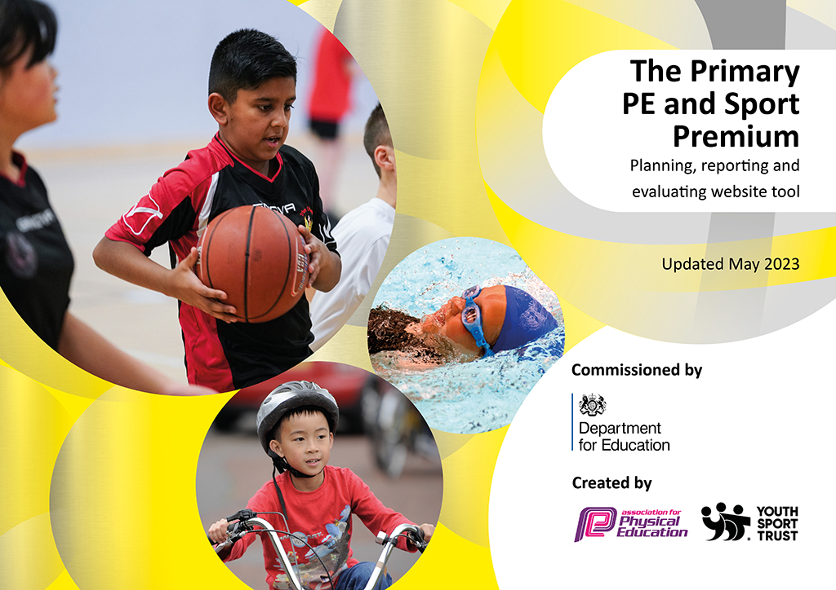
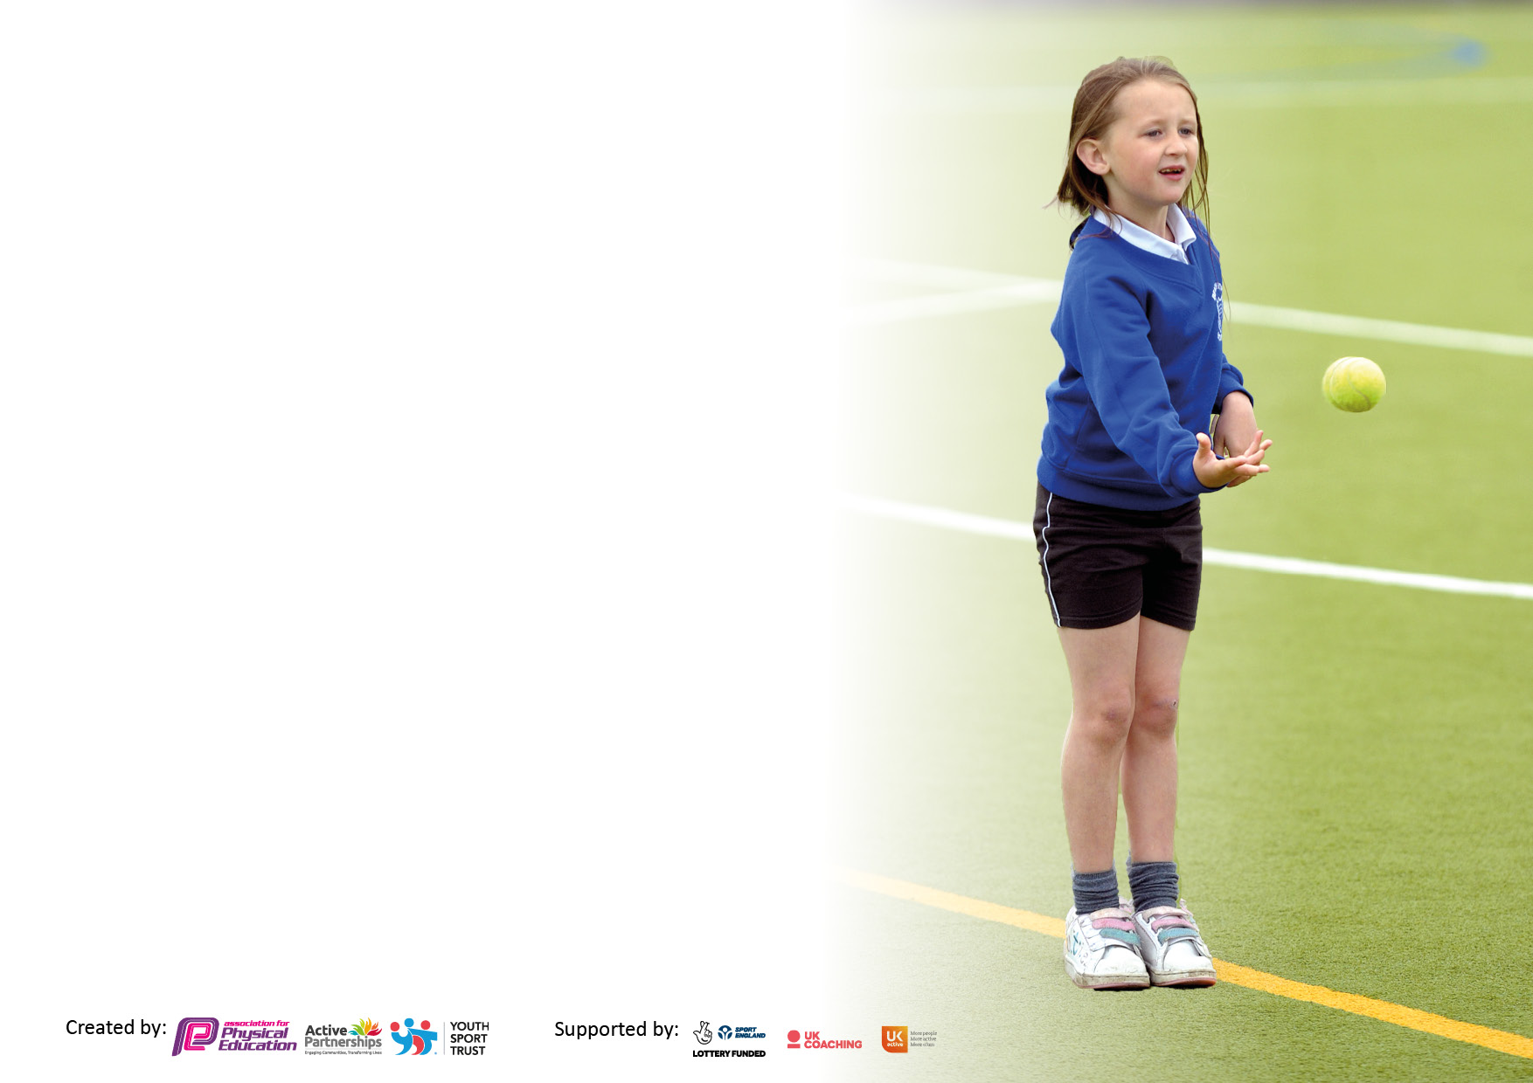

It is important that your grant is used effectively and based on school need. The Education Inspection Framework makes clear there will be a focus on ‘whether leaders and those responsible for governors all understand their respective roles and perform these in a way that enhances the effectiveness of the school’.

Under the Quality of Education judgement, Ofsted inspectors consider:
Intent - Curriculum design, coverage and appropriateness
Implementation - Curriculum delivery, teaching (pedagogy) and assessment
Impact - Attainment and progress

To assist schools with common transferable language, this template has been developed to utilise the same three headings which should make your plans easily transferable between working documents.

Schools must use the funding to make additional and sustainable improvements to the quality of Physical Education, School Sport and Physical Activity (PESSPA) they offer. This means that you should use the Primary PE and sport premium to:

- Develop or add to the PESSPA activities that your school already offers
- Build capacity and capability within the school to ensure that improvements made now will benefit pupils joining the school in future years
- The Primary PE and sport premium should not be used to fund capital spend projects; the school’s budget should fund these.

Please visit https://www.gov.uk/guidance/pe-and-sport-premium-for-primary-schools for the revised DfE guidance, including the 5 key indicators across which schools should demonstrate an improvement. This document will help you to review your provision and to report your spend. DfE encourages schools to use this template as an effective way of meeting the reporting requirements of the Primary PE and Sport Premium.

We recommend you start by reflecting on the impact of current provision and reviewing the previous spend.

Schools are required to publish details of how they spend this funding, including any underspend from 2021/2022, as well as on the impact it has on pupils’ PE and sport participation and attainment.

We recommend regularly updating the table and publishing it on your website throughout the year. This evidences your ongoing self-evaluation of how you are using the funding to secure maximum, sustainable impact. Final copy must be posted on your website by the end of the academic year and no later than the 31 July 2023.

Details with regard to funding
Please complete the table below.

Total amount carried over from 2021/22 | £18000
Total amount allocated for 2022/23 | £18560
How much (if any) do you intend to carry over from this total fund into 2023/24? | £17000
Total amount allocated for 2022/23 | £18560
Total amount of funding for 2022/23 to be reported on by 31st July 2023 | £36000
Swimming Data
Please report on your Swimming Data below.

Meeting national curriculum requirements for swimming and water safety.

N.B. Complete this section as best you can. For example, you might have practised safe self-rescue techniques on dry land which you can then transfer to the pool when school swimming restarts.
Due to exceptional circumstances priority should be given to ensuring that pupils can perform safe self-rescue even if they do not fully meet the first two requirements of the NC programme of study
What percentage of your current Year 6 cohort swim competently, confidently and proficiently over a distance of at least 25 metres?  N.B. Even though your pupils may swim in another year, please report on their attainment on leaving primary school at the end of the summer term 2023.  Please see note above | 80%
What percentage of your current Year 6 cohort use a range of strokes effectively [for example, front crawl, backstroke and breaststroke]?  Please see note above | 80%
What percentage of your current Year 6 cohort perform safe self-rescue in different water-based situations? | 100%
Schools can choose to use the Primary PE and sport premium to provide additional provision for swimming, but this must be for activity over and above the national curriculum requirements. Have you used it in this way? | Yes

Action Plan and Budget Tracking
Capture your intended annual spend against the 5 key indicators. Clarify the success criteria and evidence of impact that you intend to measure to evaluate for pupils today and for the future.

Academic Year: 2022/23 | Total fund allocated: | Date Updated: 03-07-2023
Key indicator 1: Increase confidence, knowledge and skills of all staff in teaching PE and sport |  |  |  | Percentage of total allocation:
 |  |  |  | 4.5%
Intent | Implementation |  | Impact
Your school focus should be clear on what you want the pupils to know and be able to do. What do they need to learn and to consolidate through practice: | Make sure your actions to achieve are linked to your intentions: | Funding allocated: | Evidence of impact:  What do pupils now know and what can they now do? What has changed? | Sustainability and suggested next steps:
Provide a balanced curriculum in PE and ensure staff are confident in delivering each aspect of PE. | Whole staff training in Real dance, following on from Real Gym last year.  Training of 2 teachers in how to deliver the ‘Real PE’ curriculum.  Specialist sports coach to deliver one PE lesson a week alongside the class teacher with a focus on cricket. | £834 | Teachers are more confident in delivering dance lessons, informal observation show that students are receiving dance lessons that stretch them and build on prior knowledge/ability.  Children enjoy the sessions delivered by the specialist coach and the teachers are more confident in delivering sessions on cricket. | Continue to monitor provision of Real PE and train new staff as and when the needs arise. Consider TA training.  Continue to use a specialist sports coach, may be think about different sports in upper school.
Key indicator 2: The engagement of all pupils in regular physical activity – Chief Medical Officers’ guidelines recommend that  primary school pupils undertake at least 30 minutes of physical activity a day in school |  |  |  | Percentage of total allocation:
 |  |  |  | 1.88%
Intent | Implementation |  | Impact
Your school focus should be clear on what you want the pupils to know and be able to do. What do they need to learn and to consolidate through practice: | Make sure your actions to achieve are linked to your intentions: | Funding allocated: | Evidence of impact:  What do pupils now know and what can they now do? What has changed? | Sustainability and suggested next steps:
To provide opportunities within lesson times to be active. | To ensure teachers are aware of the importance of regular movement breaks for children and that children should not be static for extended periods of time. |  | All teachers are aware of the need for regular movement breaks and the need for children to be active. | Regular movement breaks are continuing with all teachers aware of the need for this.  Staff meeting on ideas for resources and ways to make lessons more active.
To make playtimes more active. | New equipment purchased – climbing frame last year.  Coach led lunchtime clubs on a Friday. | £ 101.75 – balls for each class  £246.88 PE equipment | More than 10% of children accessed lunchtime clubs. | To increase participation lunchtime clubs switched to inter-house competitions.
Children engage fully in PE and choose to participate in additional PE activities. | Provide a minimum of 2 PE lessons per week.  Provide children additional opportunities to engage in PE through a variety of clubs and sporting competitions throughout the year.  During the month of May, children were given the opportunity to walk a mile a day. | £ reciprocal arrangement for using Game On for clubs | Timetable shows that every class is receiving at least 2 hours of PE per week.  Additional teacher led clubs include PE opportunities.  Year 6 run sports clubs in the summer term had 36 children plus the year six who delivered the provision, under the supervision of a teacher.  Cross country club had 20 participants. We participated in 2 cross country events.  Football club run by external coach, one organized football match externally. Inter house Football tournament, Netball tournament and athletics tournament held (run by a specialist coach). | Continue to offer in house sports tournaments each term.  Continue to offer PE clubs after school using an experienced coach.  Consider the mile a day challenge going forward to more months of the year.

Key indicator 3: The profile of PE and sport is raised across the school as a tool for whole school improvement |  |  |  | Percentage of total allocation:
 |  |  |  | 6.27%
Intent | Implementation |  | Impact
Your school focus should be clear on what you want the pupils to know and be able to do. What do they need to learn and to consolidate through practice: | Make sure your actions to achieve are linked to your intentions: | Funding allocated: | Evidence of impact:  What do pupils now know and what can they now do? What has  changed? | Sustainability and suggested next steps:
To increase the number of children choosing to engage in extra PE sessions. | Children’s achievement in PE is celebrated in collective worship, inter house competition encouraged friendly competition. House captains take responsibility to encourage younger year groups to engage in activities. | £1164 – Game On coach | Coach led inter-house competitions had more than half the school sign up and play. House captains encouraged children to sign up and then collected them to ensure they turned up. | Continue inter-house competitions and consider increasing the number of sports, maybe include a cricket competition.
Key indicator 4: Broader experience of a range of sports and physical activities offered to all pupils |  |  |  | Percentage of total allocation:
Intent | Implementation |  | Impact
Your school focus should be clear on what you want the pupils to know and be able to do. What do they need to learn and to consolidate through practice: | Make sure your actions to achieve are linked to your intentions: | Funding allocated: | Evidence of impact:  What do pupils now know and what can they now do? What has  changed? | Sustainability and suggested next steps:
Offer sports that enable children to try sports that they may not have come across before. Also think about sports that reflect the diverse nature of our school. | Employed a coach to teach cricket once a week to at least one class. | £ Game On included above | Teachers gain experience in how to deliver quality sessions in a sport they may not be confident in delivering. | Continue, maybe ask teachers if there are other sports they feel they would benefit from seeing delivered by a qualified coach.

Key indicator 5: Increased participation in competitive sport |  |  |  | Percentage of total allocation:
 |  |  |  | 6.29%
Intent | Implementation |  | Impact
Your school focus should be clear on what you want the pupils to know and be able to do. What do they need to learn and to consolidate through practice: | Make sure your actions to achieve are linked to your intentions: | Funding allocated: | Evidence of impact:  What do pupils now know and what can they now do? What has  changed? | Sustainability and suggested next steps:
Build on our success from last years second place in district athletics. To consider an inter-house athletics competition at lunch time.  Participate in sports competitions within the local area. | Due to the PE lead being severely ill for more than three months the deadline to enter local sports association activities was missed. We therefore offered a greater number of inter-house competitions than ever before which has proved very successful. | £1155 YST membership  £12 High viz jackets for cross country marshals | Children loved competing against each other in all three competitions held this year. This created a buzz around the school every Friday and when results were announced. | Continue to build on this and to engage in sports in the local area again.

Signed off by
Head Teacher:
Date:
Subject Leader: | Randal Stokes
Date: | 03-07-2023
Governor:
Date:

