St Edward’s Catholic Junior School

“I can do all things through Christ who strengthens me”.
Philippians 4: 13
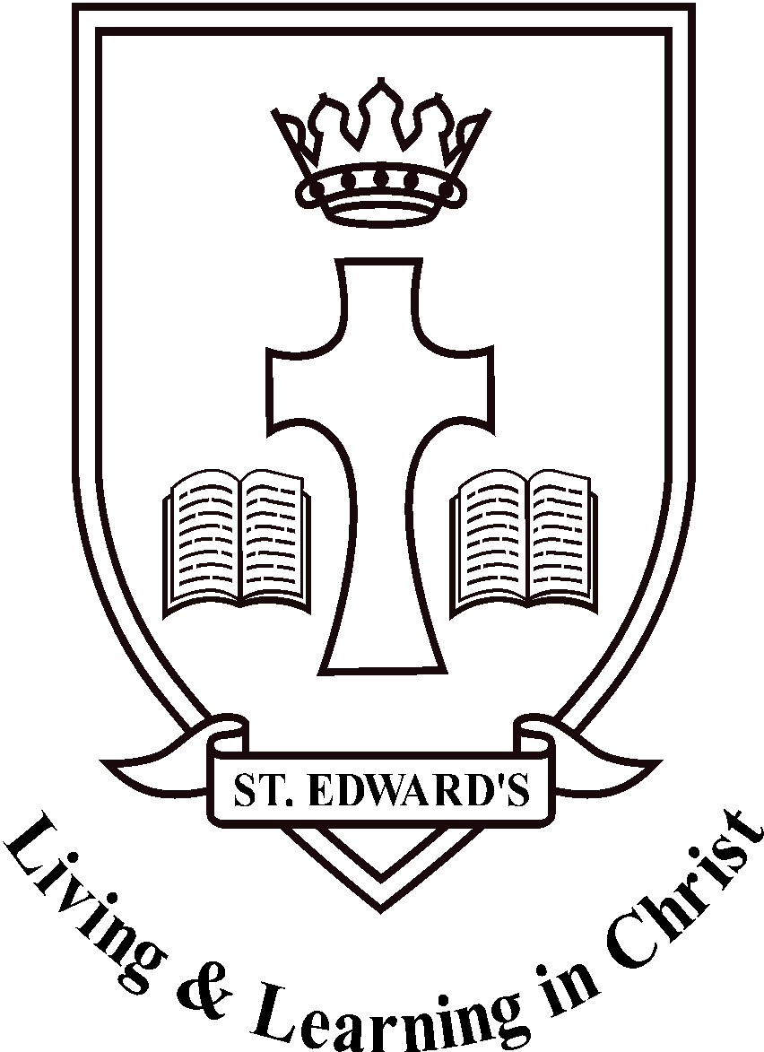

St Edward’s Catholic Junior School, School Travel Policy
We actively encourage our pupils and staff to walk, scoot or cycle to school as they:
- keep us fit and healthy
- help our pupils develop road safety skills which will keep them safe as they travel further afield and more independently
- help keep our local air clean, and our streets free from congestion
- are life skills that everyone should be able to benefit from

What we do
- We use Modeshift STARS to update and monitor our school travel plan
- We promote safe and active travel as much as possible by using our noticeboard, displays, newsletter and website at https://www.stedwards.bucks.sch.uk/
- We encourage all members of our school community to walk, cycle or travel by public transport for the journey to school. To support this we provide:
  - Cycle training (Bikeability)
  - Scooter training
  - Pedestrian training
  - Cycle parking
  - Scooter parking
  - Lockers for helmets/equipment
  - Public transport information
- Local school trips are made by public transport where possible, or on foot if the destination is close by
- We let all new pupils and their parents/carers know that we promote healthy and sustainable travel to school before the child starts at our school

What we ask of parents.
- Please encourage your child(ren) to walk, scoot or cycle to school whenever possible
- Ensure your child(ren) walk or ride sensibly and safely on the way to and from school, and to push bikes and scooters on school grounds
- Ensure that bicycles and scooters are roadworthy and properly maintained. If in doubt consult a qualified mechanic
- Consider providing your child(ren) with a cycle helmet
- Ensure your child(ren) can be seen by fitting lights to their bike by supplying them with high-visibility clothing
- Make sure your child(ren) has a lock for their bike or scooter and that they know how to use it
- Ensure you have appropriate insurance cover for your child(ren)’s bicycle or scooter as the school is not liable for any loss or damage to cycles or scooters on the premises or being used on the way to or from school
- If you travel by bus, can you get off the bus at least two stops early and walk the last part of the journey?

We understand that sometimes there is no alternative to driving to school.
- Where a car must be used we ask parents to drive only part of the way, and drop their child(ren) off away from the school so that some of the journey can be walked or scooted
  - We have a 5 / 10 minute walk zone we ask parents to part outside of
- If you do have to drive your child(ren) and stop in the near vicinity please do so legally, safely and with respect for our neighbours and local residents
  - It is not acceptable to park or wait on double yellow lines, on the school zigzags or across residential driveways for any period of time.

Please note that the decision on whether a child is competent to cycle or scoot to school is for the parent(s) or carer(s) to make. The school has no liability for any consequences arising from this decision.

What we ask of pupils
- Ask your parents if you can walk, scoot or cycle to school
- Behave in a way that shows you and the school in the best light whether walking, scooting, cycling or using public transport
- Ride or walk courteously, sensibly and safely on the way to and from school
- Push bikes and scooters on school grounds
- Check that your bike or scooter is roadworthy and properly maintained
- Consider wearing a cycle helmet
- Make sure you can be seen by using lights in the dark or bad weather and by wearing high-visibility clothing
- Make sure you have a lock for your bike or scooter and that you use it

Date: July 2023

