Want to get involved?
- Watch a video about Forest School: https://www.youtube.com/watch?v=tjzFfU43wuQ (Teacher TV: Outdoor Learning with a Forest School).

- Volunteer as a parent helper, it is great fun, rewarding and you get a hot drink and a biscuit.

- Talk with your child about what have they learned and how they feel? Sometimes they will have made something to show you.

- If you have questions or worries, contact the school office who will put you in touch with Mr Grexhammer who will be happy to call you or meet with you at school.

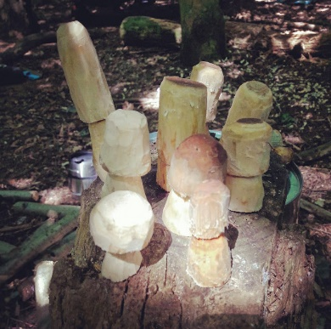

What can you do to support your child’s Forest School session?

XXX will be taking part in Forest School on Monday mornings. These sessions will begin XXXX so please remind your child to bring their Forest School clothing as we want them to be comfortable and enjoy their session. We go outside in all weathers (except when it is really windy or when there is thunder or lightning).
Please supply the following for your child:

In Spring/Summer
- Trainers, wellies or walking boots.
- Long trousers and long sleeve tops.
- Water proof coat and trousers
- Jumper or fleece
- Sunhat and sun cream.

In Autumn/Winter
- Wellies or walking boots and a second pair of thick socks.
- Long trousers and long sleeve top to keep them warm and to protect them from biting insects.
- Warm jumper or fleece.
- Water proof coat and trousers.
- Warm gloves and hat.

St Edward’s Catholic Junior School

Forest School
Information for Parents

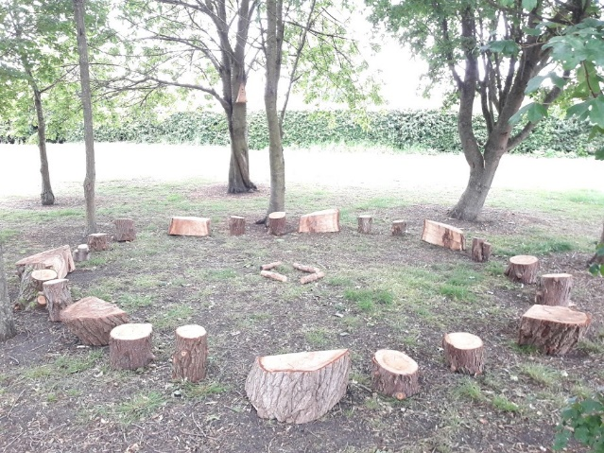

Forest School is a child-led, long-term programme of study, separate but complementary to what the children learn in school, where groups of children use practical skills to improve and maintain their well-being. They achieve this through child-centred exploring and learning, in an outdoor environment. Within this environment, children are kept safe by a fully trained Forest School leader.
What happens at our Forest School?
The first thing the children do is to dress appropriately for the weather so that they are warm and comfortable when they spend time in our specially designed Forest School Area. We have a time of prayer then discuss what we are going to do and how to stay safe. After a game, the Forest school leader will model a Forest School skill (how to whittle a stick for example). Children have the opportunity to practise this skill or choose another activity such as bug hunting, or shelter building. Lastly, we discuss what we have learned or enjoyed.
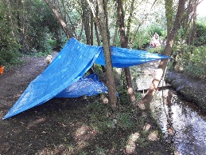

Who runs Forest School?
Mr Grexhammer is an experienced teacher and qualified Forest School leader (Forest School Leader Open Award Level 3) who has been running Forest School sessions, at various schools, for three-to- eleven–year-olds, for the last two years. He has had safeguarding training, has a First Aid in Schools certificate, an Outdoor First Aid certificate and is fully insured for all Forest School activities.
How is our Forest School good for children?
- Forest School is fun and through fun and physical play, engages children, motivates them and keeps them fit and healthy.

- Forest School is challenging; the leader supports children to learn new skills, work co-operatively and take supported risks.

- Forest School increases self-esteem; it is child-led, children make their own choices, are encouraged to persevere (which develops their resilience) and to solve problems by themselves (which increases independence).

- -Forest School is mindful and spiritual; children are given the time and space to explore their feelings and relationships. We have a time of prayer and discuss how to look after God’s amazing natural world.
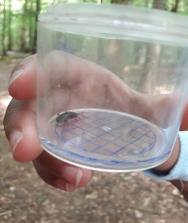
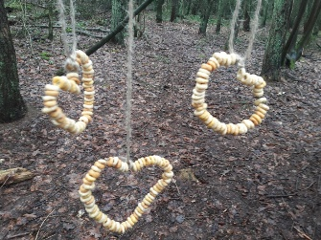

How do we keep children safe?
The risks and benefits of our Forest School area are formally recorded at the beginning of each year but are also informally thought about, observed and actioned, before and during every session.
Before each session, we look for hazards and talk about how to keep ourselves safe.
When children are ready they will be taught how to use ropes and tools safely, light a camp fire and keep it burning and occasionally (having washed their hands) use the fire to roast marshmallows (or vegetarian or Halal alternative) or other simple suitable foods.
All activities are supervised closely by an adult who will support the children in the choices they make, enabling them to become good decision makers. Staff are First Aid Trained and have access to a first aid kit outside.

