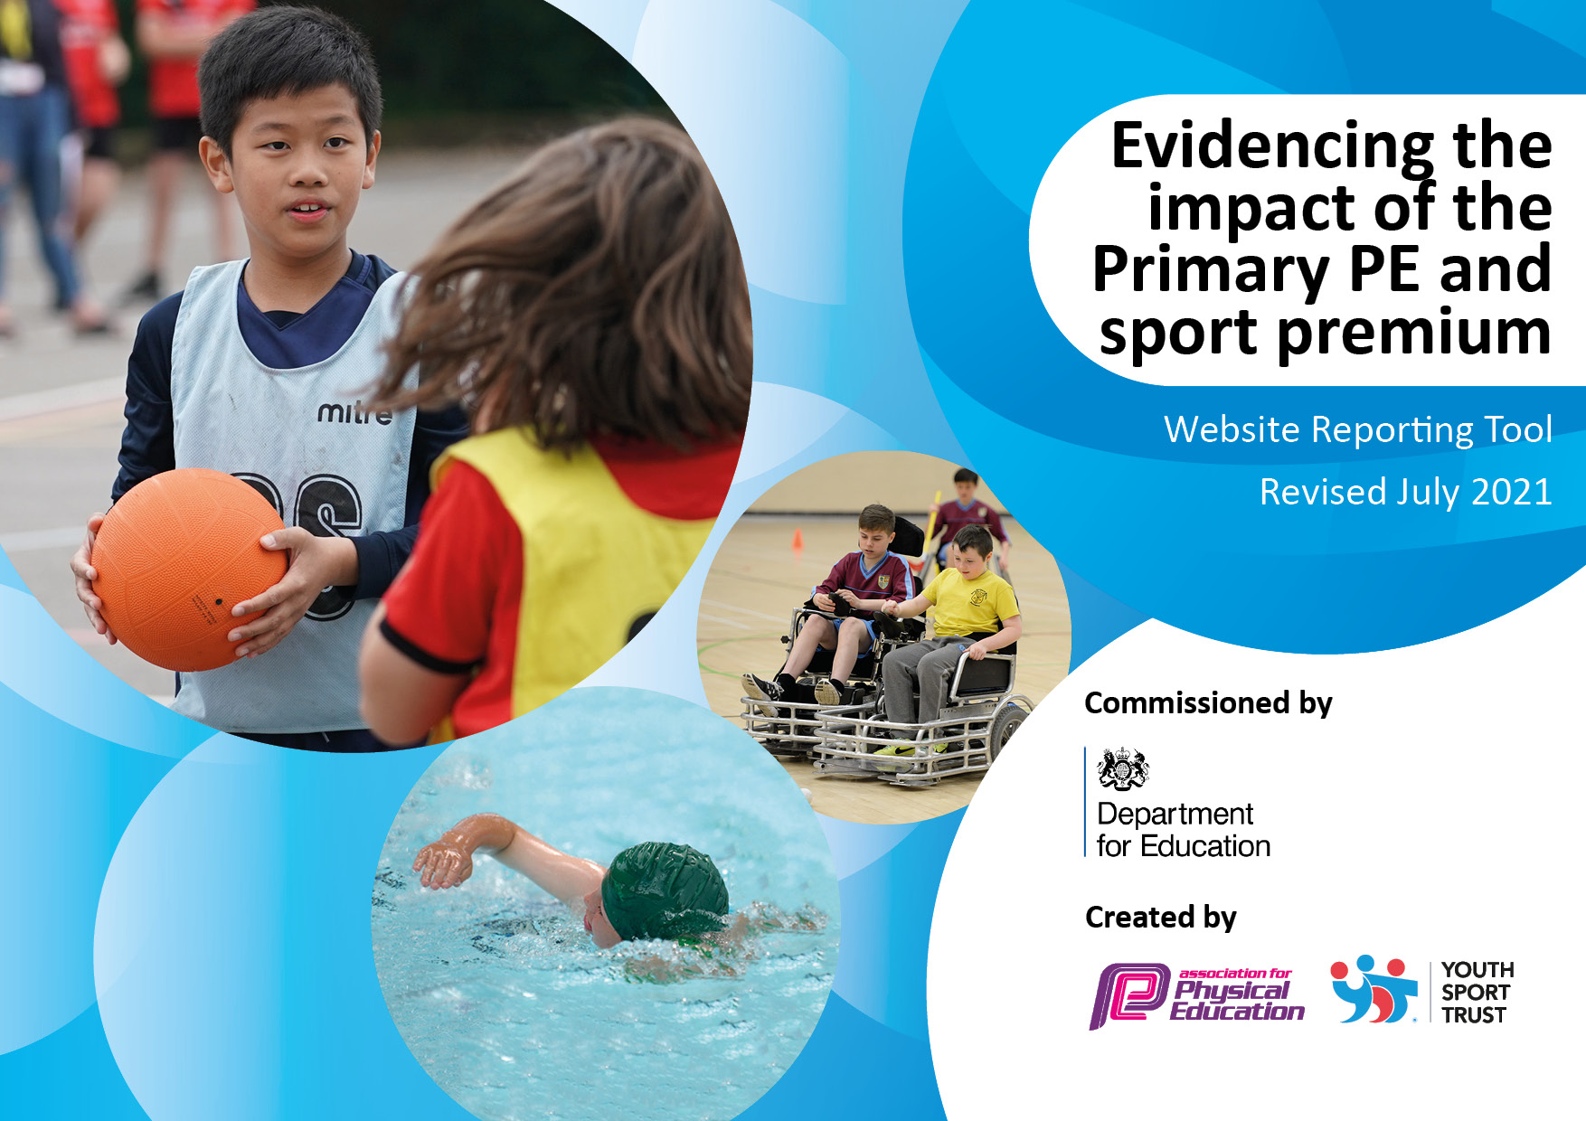
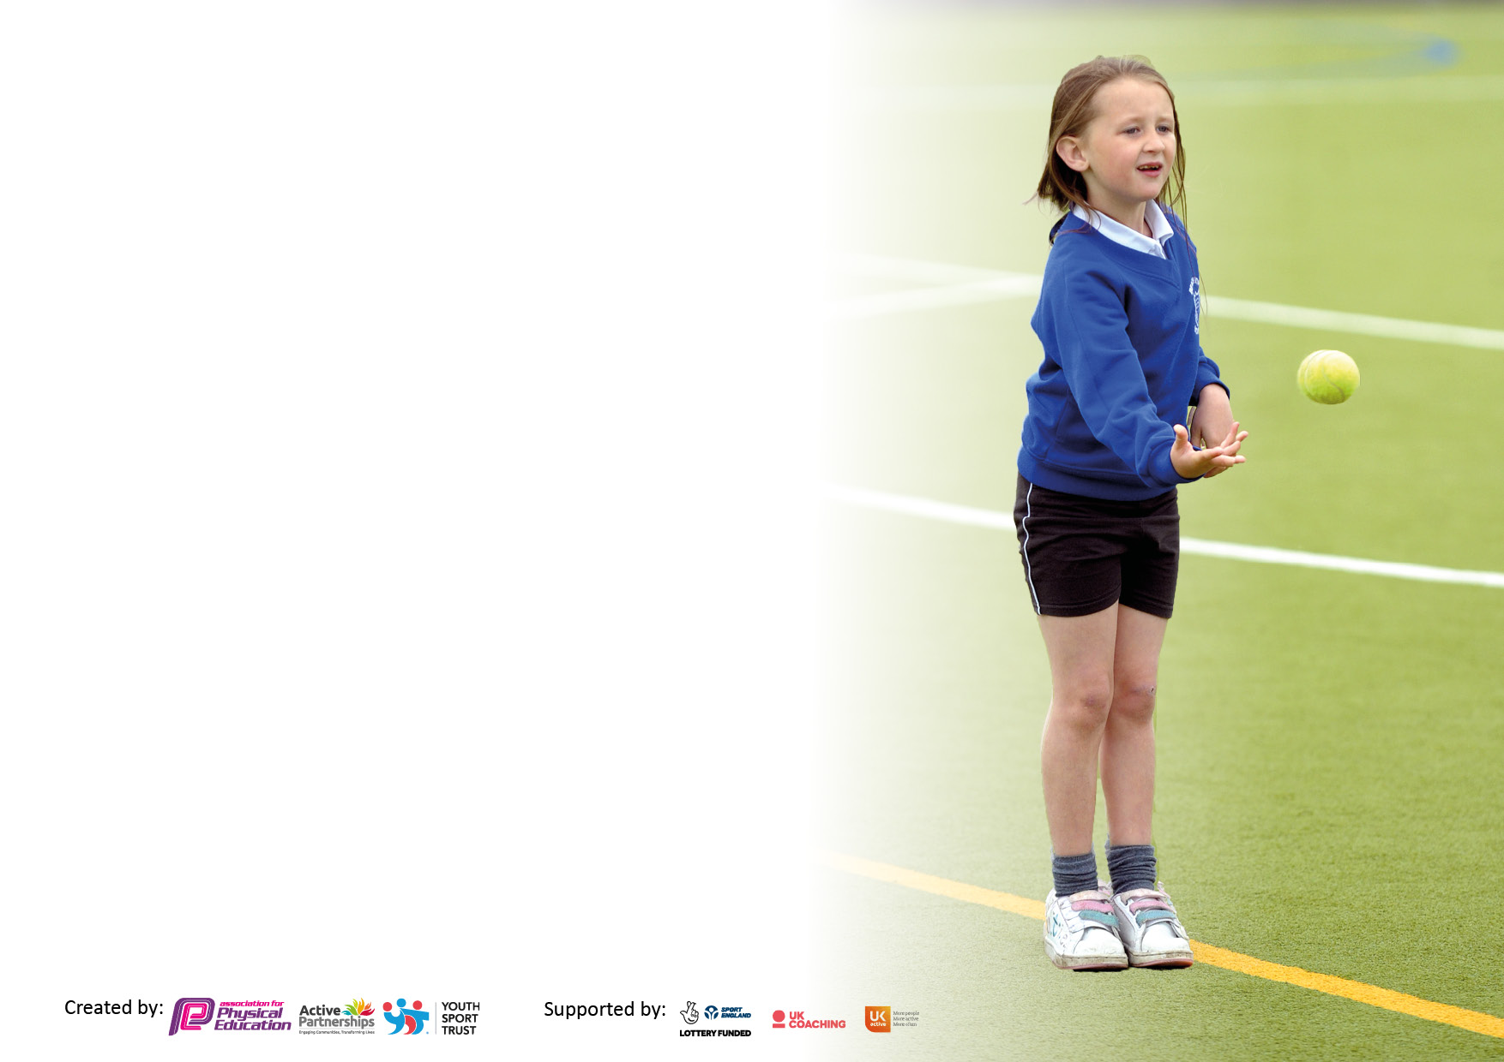

It is important that your grant is used effectively and based on school need. The Education Inspection Framework makes clear there will be a focus on ‘whether leaders and those responsible for governors all understand their respective roles and perform these in a way that enhances the effectiveness of the school’.

Under the Quality of Education Ofsted inspectors consider:
Intent - Curriculum design, coverage and appropriateness
Implementation - Curriculum delivery, Teaching (pedagogy) and Assessment
Impact - Attainment and progress

To assist schools with common transferable language this template has been developed to utilise the same three headings which should make your plans easily transferable between working documents.

Schools must use the funding to make additional and sustainable improvements to the quality of Physical Education, School Sport and Physical Activity (PESSPA) they offer. This means that you should use the Primary PE and sport premium to:

- Develop or add to the PESSPA activities that your school already offer
- Build capacity and capability within the school to ensure that improvements made now will benefit pupils joining the school in future years
- The Primary PE and sport premium should not be used to fund capital spend projects; the school’s budget should fund these.

Pleasevisitgov.ukfortherevisedDfEguidanceincludingthe5keyindicatorsacrosswhichschoolsshoulddemonstrate animprovement.Thisdocumentwillhelpyoutoreviewyourprovisionandtoreportyourspend.DfEencouragesschools to use this template as an effective way of meeting the reporting requirements of the Primary PE and sport premium.

We recommend you start by reflecting on the impact of current provision and reviewing the previous spend.

Schools are required to publish details of how they spend this funding, including any under-spend from 2019/2020, as well as on the impact it has on pupils’ PE and sport participation and attainment. All funding must be spent by 31st July 2022.

We recommend regularly updating the table and publishing it on your website throughout the year. This evidences your ongoing self-evaluation of how you are using the funding to secure maximum, sustainable impact. Final copy must be posted on your website by the end of the academic year and no later than the 31st July 2021. To see an example of how to complete the table please click HERE.
Created by: Supported by:

Details with regard to funding
Please complete the table below.

Total amount carried over from 2019/20 | £6,408.51
Total amount allocated for 2020/21 | £18590.40
How much (if any) do you intend to carry over from this total fund into 2021/22? | £12114.86 – Due to Covid
Total amount allocated for 2021/22 | £18590.40
Total amount of funding for 2021/22. To be spent and reported on by 31st July 2022. | £30705.26
Swimming Data
Please report on your Swimming Data below.

Meeting national curriculum requirements for swimming and water safety.

N.B. Complete this section to your best ability. For example you might have practised safe self-rescue techniques on dry land which you can then transfer to the pool when school swimming restarts.
Due to exceptional circumstances priority should be given to ensuring that pupils can perform safe self rescue even if they do not fully meet the first two requirements of the NC programme of study
What percentage of your current Year 6 cohort swim competently, confidently and proficiently over a distance of at least 25 metres?  N.B. Even though your pupils may swim in another year please report on their attainment on leaving primary school at the end of the summer term 2021.  Please see note above | 80%
What percentage of your current Year 6 cohort use a range of strokes effectively [for example, front crawl, backstroke and breaststroke]?  Please see note above | 80%
What percentage of your current Year 6 cohort perform safe self-rescue in different water-based situations? | 100%
Schools can choose to use the Primary PE and sport premium to provide additional provision for swimming but this must be for activity over and above the national curriculum requirements. Have you used it in this way? | Yes £2499.20 for catch up swimming for children who didn’t achieve 25m by end of year 5.

Action Plan and Budget Tracking
Capture your intended annual spend against the 5 key indicators. Clarify the success criteria and evidence of impact that you intend to measure to evaluate for pupils today and for the future.

Academic Year: 2020/21 | Total fund allocated: | Date Updated:
Key indicator 1: The engagement of all pupils in regular physical activity – Chief Medical Officers guidelines recommend that primary school pupils undertake at least 30 minutes of physical activity a day in school |  |  |  | Percentage of total allocation:
 |  |  |  | 48.27%
Intent | Implementation |  | Impact
Your school focus should be clear what you want the pupils to know and be able to do and about  what they need to learn and to  consolidate through practice: | Make sure your actions to achieve are linked to your intentions: | Funding allocated: | Evidence of impact: what do pupils now know and what can they now do? What has changed?: | Sustainability and suggested next steps:
To provide opportunities within lesson times to be active. | -To involve SLT/ PE Co-ordinator to encourage and provide or purchase materials to use  -Teachers to implement these strategies within lessons | £ | All teachers are aware of the need for regular movement breaks and the need for children to be active.  Resources have been limited due to covid-19 and the limited number of items the children can touch. | Regular movement breaks are continuing with all teachers aware of the need for this.  Start to use resources for active lessons now covid-19 is not as high a priority.
To make playtimes more active. | -To involve PE Co-ordinator and lunch time staff  -Equipment to be sorted specifically for use at lunch times  -Lunch time staff to organise themselves so that small playground can be open with equipment on it in winter and in summer that more equipment is on offer  - Think about lunch time coaches. Would this work?  -Think about implementing House Captains and how this could be used to promote activity in lunch times  -Each year group to have a football-free arena break time each week to promote the use of different sports | £13354.80  Cost of new climbing frames  £1086  Cost of coach led lunch time club. Friday lunch time coach for cross country/ Cricket sessions  -Equipment may be purchased | -Children will choose to play with equipment  -They will use equipment in a way that means they increase their heartrate and work on their ability to use team work  New outdoor adventurous climbing equipment installed. | Lunchtime club is being used by over 10% of the school, this also gives us a free PE lesson for staff CPD.  Limited amount of equipment children can use at break and lunch times due to covid-19. This needs to be addressed next academic year.  Arena times still appear to be popular and each class has one break and lunch session per week in the arena.  Going forward we need to consider play leaders at lunch time.
To encourage active journey’s to and from school, and active breaktimes. | -SLT and PE Co-ordinator and all staff members to encourage this  -Bikeability will be offered to Year 5 and 6  -Activity trackers to be bought and introduced for use in school. Track steps of each class and build an element of competition.  - bike and scooter stands will be monitored to see how popular they are | £379.80  Cost of activity trackers | Bike and scooter stands remain popular, particularly when the weather is good.  No further work on travel methods have been carried out due to covid-19. | A class set of activity trackers has been purchased but yet to be issued due to covid-19. They need to be introduced in the next academic year.
Key indicator 2: The profile of PESSPA being raised across the school as a tool for whole school improvement |  |  |  | Percentage of total allocation:
 |  |  |  | 0%
Intent | Implementation |  | Impact
Your school focus should be clear what you want the pupils to know and be able to do and about  what they need to learn and to  consolidate through practice: | Make sure your actions to achieve are linked to your intentions: | Funding allocated: | Evidence of impact: what do pupils now know and what can they now do? What has changed?: | Sustainability and suggested next steps:
To improve recording of assessment data for PE | -To involve DHT and PE Co-ordinator  -To discuss with staff how to complete assessment forms which are the same as all other foundation subject assessment grids  -To discuss with staff the frequency and expectations of what passing certain skills look like  -To monitor the assessment sheets for PE and check they are being filled out correctly  -SEN children with areas of weakness within their gross motor skills to use an assessment system within their interventions to target these and therefore support them in accessing in PE lessons | £150.00 | -Assessment sheets will be used well throughout the year and where skills overlap areas you can see some progression  -Teachers will be able to see any gaps from previous years based on skills that may need to be developed with their classes and target lessons to work on these | Real PE has been invested in again with the purchase of their ‘Jasmine’ platform which allows teachers to track progress in PE. Staff training carried out in the summer term by Real PE.  Staff will need to be reminded in September about this.
An increased whole school focus on living and maintaining a healthy active lifestyle. | -To encourage the sports committee to share their ideas within meetings to impact levels of activity during break and lunch times  -To support mental health and wellbeing for all pupils, specifically those with SEN or SEMH.  -To teach about healthy food choices and healthy active choices out of school |  | -Assemblies on a healthy active lifestyle  -Children will be able to talk confidently about food choices and activity choices which will benefit them | Due to lack of assemblies because of covid-19 these did not happen. We need to ensure they do in the next academic year.  Year 3’s final focus in the summer term is ‘Healthy Living’.

Key indicator 3: Increased confidence, knowledge and skills of all staff in teaching PE and sport |  |  |  | Percentage of total allocation:
 |  |  |  | 6.58%
Intent | Implementation |  | Impact
Your school focus should be clear | Make sure your actions to | Funding | Evidence of impact: what do | Sustainability and suggested
what you want the pupils to know | achieve are linked to your | allocated: | pupils now know and what | next steps:
and be able to do and about | intentions: |  | can they now do? What has
what they need to learn and to |  |  | changed? :
consolidate through practice:
To provide opportunities for all staff to develop their knowledge | -Share resources from Youth Sport Trust with staff when available  -To remind staff to look at videos for PE skills on Real PE and to read the PE Hub plans carefully and to ask PE Co-ordinator if they are unsure of how to teach  -PE Co-ordinator to look for courses and send relevant staff on them if needed  -PE co-ordinator to work with TA’s to best advice how to support within lessons | £545 - Real PE subscription.  £1014 - Cost of real PE training | -Staff will feel more confident in the areas of sport they are teaching  -Staff will be observed at least once a year by PE  Co-ordinator to monitor best practise and share with all staff | Real gym training took place in October 2021 – there was a noticeable improvement in gym teaching throughout the school.  Real dance training has been booked for October 2022.
To improve the knowledge of all members of staff in regards to supporting swimming | -PE Co-ordinator and SLT to send staff on relevant courses | £ 460  Cost of swimming courses | 2X adult trained (Mrs T) plus 2X online refresher courses. | Additional staff to be trained early next academic year.
Key indicator 4: Broader experience of a range of sports and activities offered to all pupils |  |  |  | Percentage of total allocation:
 |  |  |  | 0.75%
Intent | Implementation |  | Impact
Your school focus should be clear | Make sure your actions to | Funding | Evidence of impact: what do | Sustainability and suggested
what you want the pupils to know | achieve are linked to your | allocated: | pupils now know and what | next steps:
and be able to do and about | intentions: |  | can they now do? What has
what they need to learn and to |  |  | changed?:
consolidate through practice:
Additional achievements:  To encourage a range of sports and activities offered in curriculum time | Real PE provides a broad range of skills and activities. Real Gym training to all staff to ensure consistency of approach and developing skills between year groups.  Planning using PE Hub provides a range of different ‘traditional’ sports for each year group.  Specialist coach booked for teaching year 3 & 5 cricket lessons. | £230  Cost of PE Hub membership  No cost for coach for Year3 & 5 Cricket – reciprocal arrangement. | Children are more confident within PE lessons and teaching builds on skills from one year to the next. | Further training on Dance through Real PE
To encourage a range of physical extra-curricular activities | Subsidise Game On sports coaching and try to offer at least 2 different sports from this | N/A | 20% of children signed up to the coach run sessions. | Due to pandemic extra-curricular clubs were limited. Next academic year look into starting dance club again and encourage teachers to run active clubs.

Key indicator 5: Increased participation in competitive sport |  |  |  | Percentage of total allocation:
 |  |  |  | 0.11%
Intent | Implementation |  | Impact
Your school focus should be clear | Make sure your actions to | Funding | Evidence of impact: what do | Sustainability and suggested
what you want the pupils to know | achieve are linked to your | allocated: | pupils now know and what | next steps:
and be able to do and about | intentions: |  | can they now do? What has
what they need to learn and to |  |  | changed?:
consolidate through practice:
Ensure that all children are offered the opportunity to compete in competitive sports and that they are encouraged to do their best and compete in a sportsman like manner. | Offer children the opportunity to compete in cross country events.  Attend district athletics and hold whole school trials beforehand.  Sports day to be competitive within year groups. | £35 cost of affiliation | Limited opportunity for inter-schools’ competition due to pandemic.  We entered a full team into the district cross country event.  We held trials for district athletics during lunch times. In total over 180 children trialled for district athletics.  At district athletics we came second. | To build on our successes from last year and participate in events that are held.  To run a cross country club.  To build on our success in district athletics.

Signed off by
Head Teacher: | S Harris
Date: | 27/09/2022
Subject Leader: | Randal Stokes
Date:
Governor:
Date:

