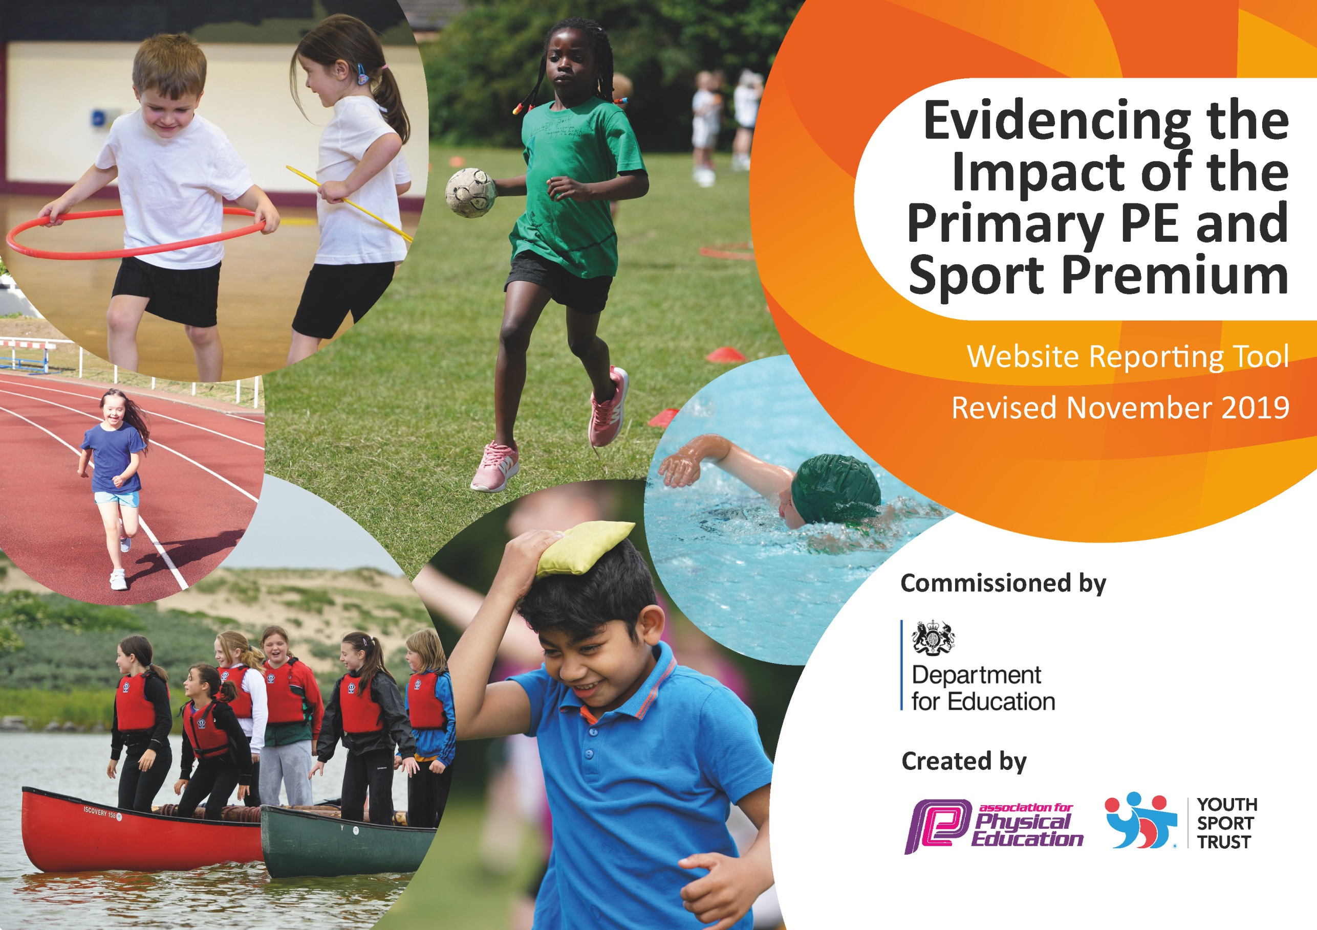
July 2021
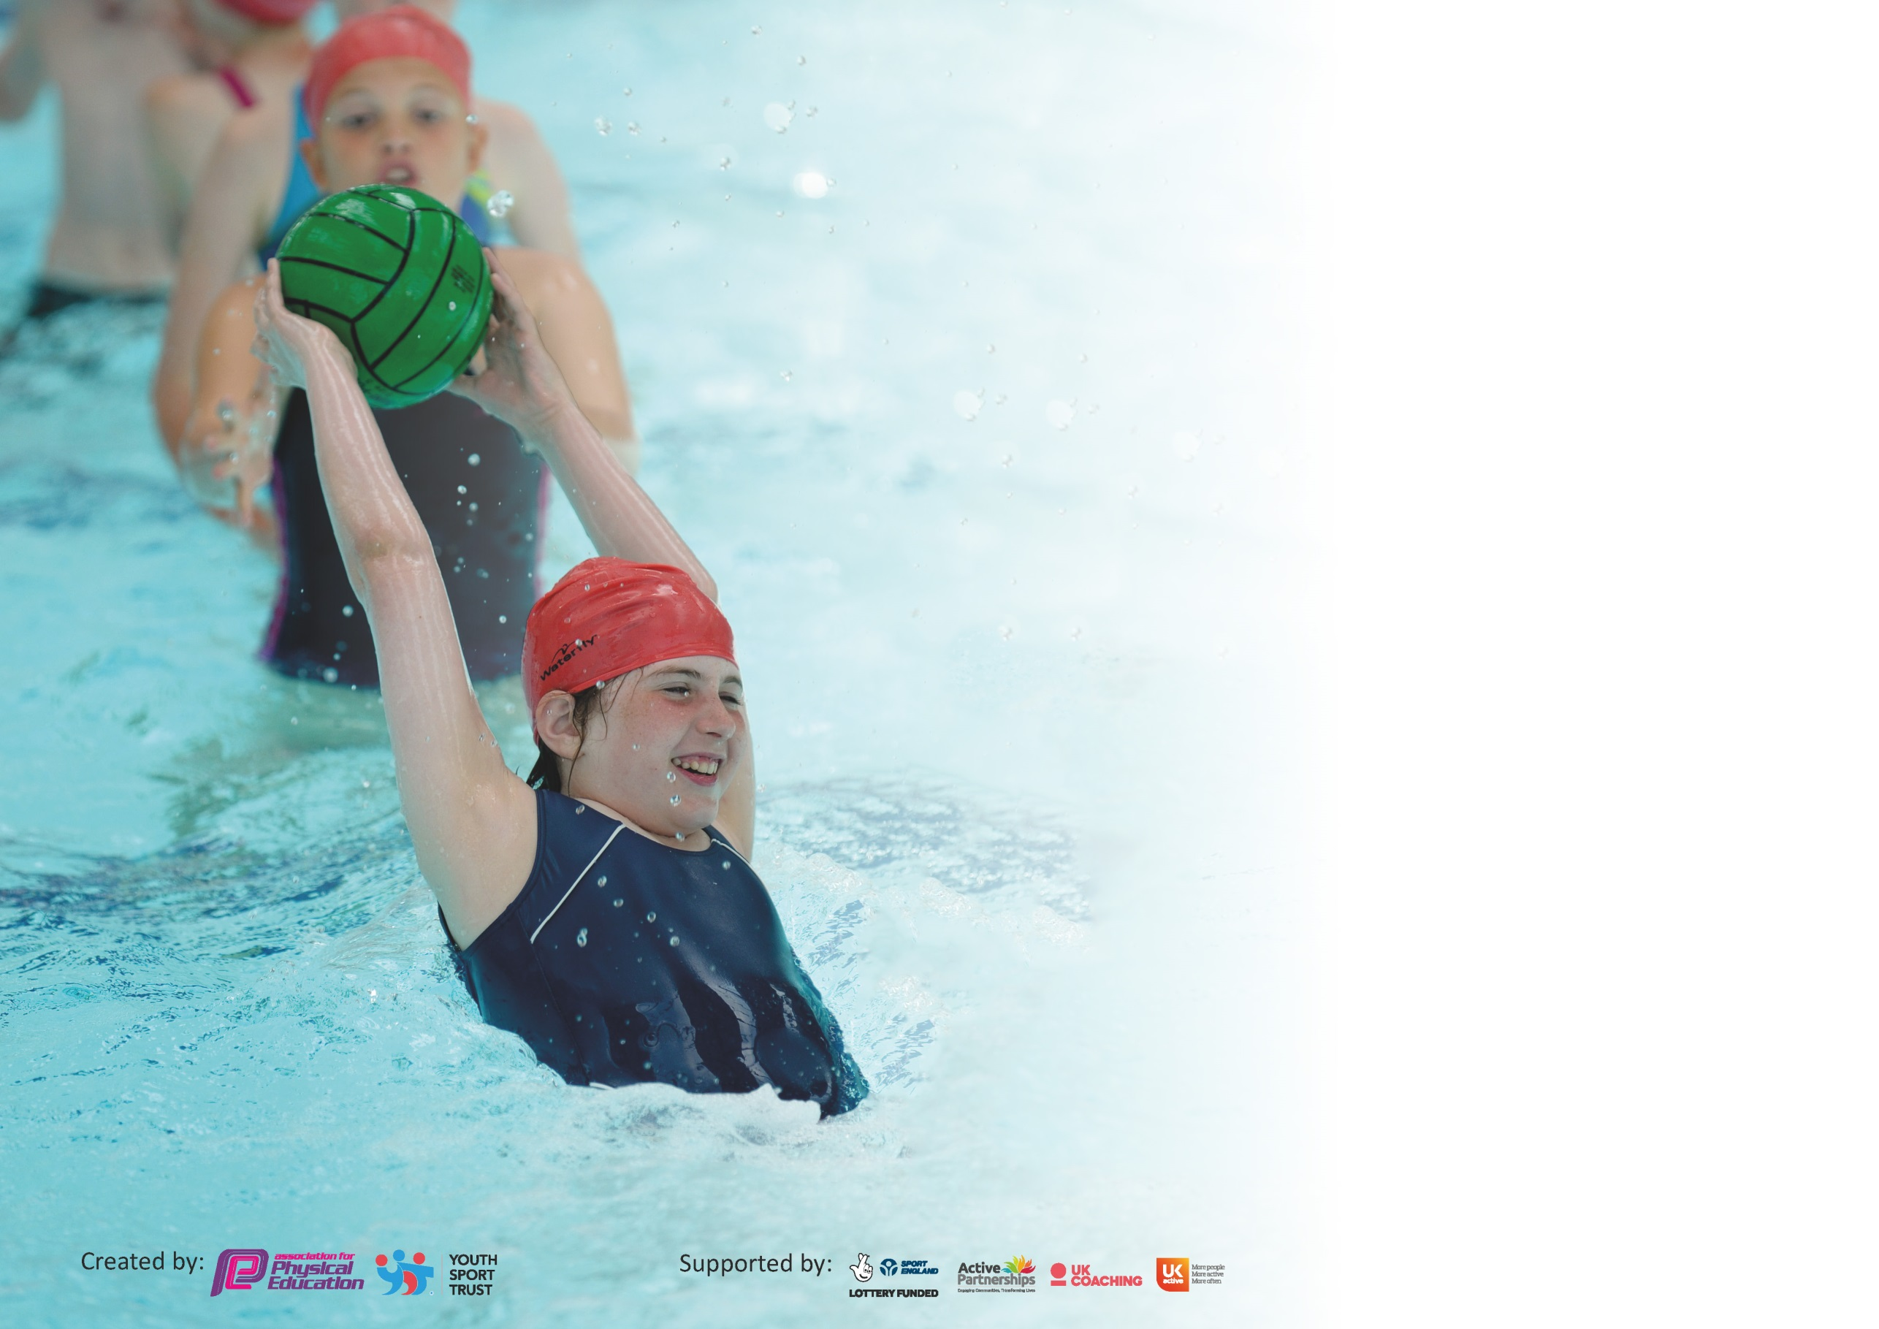

It is important that your grant is used effectively and based on school need. The Education Inspection Framework (Ofsted 2019 p64) makes clear there will be a focus on ‘whether leaders and those responsible for governors all understand their respective roles and perform these in a way that enhances the effectiveness of the school’.

Under the Quality of Education criteria (p41) inspectors consider the extent to which schools can articulate their curriculum (INTENT), construct their curriculum (IMPLEMENTATION) and demonstrate the outcomes which result (IMPACT).

To assist schools with common transferable language this template has been developed to utilise the same three headings which should make your plans easily transferable between working documents.

Schools must use the funding to make additional and sustainable improvements to the quality of Physical Education, School Sport and Physical Activity (PESSPA) they offer. This means that you should
use the Primary PE and Sport Premium to:

- Develop or add to the PESSPA activities that your school already offer
- Build capacity and capability within the school to ensure that improvements made now will benefit pupils joining the school in future years

Please visit gov.uk for the revised DfE guidance including the 5 key indicators across which schools should demonstrate an improvement. This document will help you to review your provision and to report your spend. DfE encourages schools to use this template as an effective way of meeting the reporting requirements of the Primary PE and Sport Premium.

We recommend you start by reflecting on the impact of current provision and reviewing the previous spend.

Schools are required to publish details of how they spend this funding as well as on the impact it has on pupils’ PE and sport participation and attainment by the end of the summer term or by 31st July 2021 at the latest.

We recommend regularly updating the table and publishing it on your website throughout the year. This evidences your ongoing self-evaluation of how you are using the funding to secure maximum, sustainable impact. Final copy must be posted on your website by the end of the academic year and no later than the 31st July 2020. To see an example of how to complete the table please click HERE.

Support for review and reflection - considering the 5 key indicators from DfE, what development needs are a priority for your setting and your pupils now and why? Use the space below to reflect on previous spend and key achievements and areas for development.

Key achievements to date until July 2021: | Areas for further improvement and baseline evidence of need:
88% of year 6 achieved 25m swimming - Higher percentage than a previous year – Due to covid-19 little evidence of swimming achievement below year 6, however additional support planned for 2021-22 academic year.  Additional swimming sessions booked at Gutmann. | Encourage catch up sessions for Year 6  If there is a class that is significantly weaker than the other – consider giving them some additional time in the pool and stopping the other class early.

Meeting national curriculum requirements for swimming and water safety.
What percentage of your current Year 6 cohort swim competently, confidently and proficiently over a distance of at least 25 metres?  N.B. Even though your pupils may swim in another year please report on their attainment on leaving  primary school at the end of the summer term 2020. | 88%
What percentage of your current Year 6 cohort use a range of strokes effectively [for example, front crawl, backstroke and breaststroke]? | 88% Swimmers who can swim 20 metres or more.  82% could swim 25m using a variety of strokes.
What percentage of your current Year 6 cohort perform safe self-rescue in different water-based situations? | 88%  All children took part in self-rescue situations but only those who can swim 20 metres or more have been counted here
Schools can choose to use the Primary PE and Sport Premium to provide additional provision for swimming but this must be for activity over and above the national curriculum requirements. Have you used it in this way? | Yes  Each year group that missed out on swimming due to covid-19 will have booster swimming lessons on top of their normal sessions from Autumn 2021. In addition, year 6 children had booster sessions from summer 2021.

Action Plan and Budget Tracking
Capture your intended annual spend against the 5 key indicators. Clarify the success criteria and evidence of impact that you intend to measure to evaluate for pupils today and for the future.

Academic Year: 2020/21 | Total fund allocated: £ 18,590.40 | Date Updated: 04.07.21
Key indicator 1: The engagement of all pupils in regular physical activity – Chief Medical Officer guidelines recommend that primary school pupils undertake at least 30 minutes of physical activity a day in school |  |  |  | Percentage of total allocation:
Intent | Implementation |  | Impact | 7.25%
Your school focus should be clear what you want the pupils to know and be able to do and about  what they need to learn and to  consolidate through practice: | Make sure your actions to achieve are linked to your intentions: | Funding allocated:  £1155 -Youth sports conference.  £117 - Rope repairs on outdoor play equipment.  £74.96 - Tag Rugby equipment  £1,346.96 Total | Evidence of impact: what do pupils now know and what can they now do? What has changed? : | Sustainability and suggested next steps:
To provide opportunities within  lesson times to be active. | Children will be more active around  the classroom within lessons  They will undertake at least 2 active  starters for the core subjects of  English and Maths per week and  one active starter for another  subject  PE Co-ordinator needs time to  show and promote various  strategies used in lessons |  | Children now have increased  access to movement breaks  within the classroom. (Outside the classroom due to Covid)  They take part in Active Maths  starters using our Maths of the  Day subscription. They also use  free resources such as BBC  Supermovers regularly as  starters or revision within  Maths, English, Science and MFL.  As well as this, Joe Wick’s  Classroom workouts are used  Online during lockdown While in school regular runs around the field and playground.  4 under desk pedal bikes were  purchased for a trial within year  6 lessons. It does mean that  children can pedal whilst  listening to instructions. This has  had mixed results. For some  children it has been incredibly helpful, for others, it is too much of a distraction. | Hold a staff meeting or lead  part of the staff meeting in  order to remind teachers  about the importance of these  next steps. Look at the  website: https://www.crosscurricularorienteering.co.uk and consider whether this would help learning across the curriculum in a more active way also.  Find more free resources that can be shared.  Carry out a monitoring week  across classes asking them to  record all activity in a week and compare and reflect on this (this was planned but didn’t happen due to Covid-19.)  Concerning the pedal bikes, they are not a sustainable option within the classroom. Consider making them part of a sensory circuit or getting those children who are unable to take part in the PE lesson due to medical or other reasons to sit and cycle whilst others take part.
To make playtimes more active. | Children will choose to play with  equipment outside. Equipment is  specifically bought with a playground focus  They will use equipment in a way that means they increase their heartrate and work on their ability to use team work  Lunch time staff to organise themselves so that small playground  can be open with equipment on it in winter and in summer that more  equipment is on offer |  | Reorganisation of playground  staff has been successful and  allowed for more children to  be active with a variety of  equipment  The children are clearly more active at lunch time. | Consider equipment that is  being bought. Some  equipment is very popular but  breaks easily. Is there a more  sustainable alternative? Does  it need to be plastic? Due to covid little playground equipment has been used.  A ‘paint marking machine’ was purchased in order to paint a 500m track boundary around the field so that the children would be allowed to run this and visualise the distance better. (This did not happen this academic year due to Covid-19)
To encourage active journeys to and from school. | Bikeability will be offered to Year 5 and 6  Living Streets TravelTracker will be purchased and used to promote this  Bike and scooter stands have been installed. More children will make an effort to walk, ride or scoot to school. The bike and scooter stands will be used more frequently |  | Bikeability was offered to Year 5 and 6.  An assembly was held which focused on coming to schools in different ways and the importance of having at least 30 active minutes a day. This led more children to encourage their families to walk or park further from the school.  The bike and scooter stands are used by more and more children. Those who enter in to Year 6 tend to use them more as they become trusted to travel to and from school by themselves. There is also an increase in the amount who walk in this year group. | Living Streets TravelTracker was not purchased or used to promote this. (This did not happen this academic year due to Covid-19)  The bikes and scooter stands are sustainable and safer than the old ones.  Consider promoting and offering Bikeability to all the year groups. Carry out a survey for all year groups based on journeys to and from school and the reasons for why they travel the way they do.
Key indicator 2: The profile of PESSPA being raised across the school as a tool for whole school improvement |  |  |  | Percentage of total allocation:
 |  |  |  | 1.25%
Intent | Implementation |  | Impact
Your school focus should be clear what you want the pupils to know and be able to do and about  what they need to learn and to  consolidate through practice: | Make sure your actions to achieve are linked to your intentions: | Funding allocated:  £230 – PE Hub annual subscription  Real PE subscription suspended due to Covid. | Evidence of impact: what do pupils now know and what can they now do? What has changed? : | Sustainability and suggested next steps:
To improve recording of assessment data for PE | To discuss with staff how to complete assessment forms which are now the same as all other foundation subject assessment grids  To discuss with staff the frequency and expectations of what passing certain skills look like  To monitor the assessment sheets for PE and check they are being filled out correctly. Assessment sheets will be used well throughout the year and where skills overlap areas you can see some progression  SEN children with areas of weakness within their gross motor skills to use an assessment system within their interventions to target these and therefore support them in accessing in PE lessons |  | Children know the skills and criteria they are being assessed against and use these when planning their final performance or refer to and perform these in their final assessed lesson.  Those children with an SEN requirement within their gross motor skills are assessed based on a separate criteria and then interventions are based on working on these skills. This year, the trial group have made significant progress which has also shown within the PE lessons themselves. | Teachers can see any gaps from previous years based on skills that may need to be developed with their classes and target lessons to work on these. This will be increasingly important as we focus on living with/recovering from the impact of Covid-19.  Assessment grids are sustainable and up to date based on what the teachers are now teaching. Consider the impact on this next year – socially distanced lessons or no sharing of equipment rules will affect this. May need a standalone fitness assessment sections based on independent non sport based skills.
An increased whole school focus on living and maintaining a healthy active lifestyle. | To encourage the sports committee to share their ideas within meetings to impact levels of activity during break and lunch times  To support mental health and wellbeing for all pupils, specifically those with SEN or SEMH.  To teach about healthy food choices and healthy active choices out of school. To hold assemblies on a healthy active lifestyle and encourage discussion within PE and PSHE lessons and across the curriculum.  Children will be able to talk confidently about food choices and activity choices which will benefit them. |  | Our Maths of Day subscription is used to help raise attainment in Maths and has helped some disengaged boys in particular to view Maths in a different way.  Throughout the Covid-19 lockdowns, Joe Wicks’ videos have been followed both by the key workers and those children at home. We have some children who did not yet missed a single video. We have also seen a majority of children take up running with their parents and can now run a 5k, or they can now cycle for longer periods.  A Sports Day was held for all classes separately due to Covid. This was very successful with a majority of children taking part alongside family members and posting their results. | Co-ordinate with the SENCo to develop a sensory circuit that could be used for SEN and SEMH children when needed.  Encourage staying active at home during and after the Covid-19 recovery phase. Make sure those children who participate are visibly praised.  Consider ways to encourage the whole family to be active for a school event. A charity walk, cycle, run or scoot for CAFOD?

Key indicator 3: Increased confidence, knowledge and skills of all staff in teaching PE and sport |  |  |  | Percentage of total allocation:
 |  |  |  | 6.2%
Intent | Implementation |  | Impact
Your school focus should be clear | Make sure your actions to | Funding | Evidence of impact: what do | Sustainability and suggested
what you want the pupils to know | achieve are linked to your | allocated: | pupils now know and what | next steps:
and be able to do and about | intentions: |  | can they now do? What has
what they need to learn and to |  |  | changed?
consolidate through practice: |  | £1155 – Youth sports membership.
To provide opportunities for all staff to develop their knowledge | Share resources from Youth Sport Trust with staff when available  To remind staff to look at videos for PE skills on Real PE and to read the PE Hub plans carefully and to ask PE Co-ordinator if they are unsure of how to teach  PE Co-ordinator to look for courses and send relevant staff on them if needed  PE Co-ordinator to work with TA’s to best advice how to support within lessons  Staff will be observed at least once a year by PE Co-ordinator to monitor best practise and share with all staff |  | Resources have been shared and promoted within a Staff meeting.  TA’s are usuing different strategies to support within PE – specifically to support those children with a gross and fine motor skill need or another SEN need.  The PE Hub plans are fun – the children love to play some of the warm up games and have been spotted playing them at break and lunch times by themselves. This shows that staff have been teaching them well and showing enjoyment.  New PE Coordinator attended a twilight refresher course for Real PE. | CDP for real GYM booked for 2021-22.  The YST membership needs time to be explored at a greater length. The PE Co-ordinator has had limited time to do this due to normal school time restraints and Covid-19.  The PE Hub plans are clearly improving the standard of PE being taught within the school. Consider how to progress the lesson last of this within each year group to allow of competition between classes and groups. Year 6 have managed this well and this should be rolled out across the school.  Staff have not been observed due to Covid-19. To complete next year with a mixture of Real PE and PE Hub sport specific lessons to see a broad range of impact.
To improve the knowledge of all members of staff in regards to supporting swimming | PE Co-ordinator to look for courses and send relevant staff on them if needed  PE Co-ordinator to work with TA’s to best advice how to support within lessons |  | 6 members of staff are swim trained.  Additional swimming sessions have been booked to allow catch up for classes that have missed out on curriculum swimming. | 2 additional members of staff to be swim trained.
To improve the knowledge and effectiveness of PE  co-ordinator | PE co-ordinator will have a day or equivalent of this out of class each term to work on improving PE. Additional time will be given nearer larger sporting events.  To review equipment and sustainability of purchases  To review the curriculum and sports provided. Curriculum map will offer opportunities will children to show progression but also experience new sports  PE co-ordinator to work with SENCo to develop or adapt interventions which will aid our children with SEN to contribute more within PE lessons alongside their peers.  Assessment sheets will be monitored termly  Observations of staff to happen at least once per year |  | PE Co-ordinator did not receive the total amount of time out of class due to Covid 19. Originally, it was budgeted for 2 afternoons and 4 days however only 2 afternoons of this was spent.  Curriculum map has been reviewed and now all children have a broad mix of skills taught within each year group. Teachers have used the plans well to teach new sports.  PE Co-orinator has worked with SENCo and TA’s to work on interventions. Outcomes mentioned above. | Ensure all children with an SEN need for gross motor skills now use the assessment sheet and targeted interventions happen across the school based on success shown from the trial group.  Review the curriculum map again in the light of Covid-19 and implications going forward on equipment used. Also consider reviewing it and moving sports around to help aid assessment gaps missed due to Covid-19.
Key indicator 4: Broader experience of a range of sports and activities offered to all pupils |  |  |  | Percentage of total allocation:
 |  |  |  | 49.5%
Intent | Implementation |  | Impact
Your school focus should be clear | Make sure your actions to | Funding | Evidence of impact: what do | Sustainability and suggested
what you want the pupils to know | achieve are linked to your | allocated: | pupils now know and what | next steps:
and be able to do and about | intentions: |  | can they now do? What has
what they need to learn and to |  |  | changed?
consolidate through practice: |  | £9200.00 – outdoor gym equipment.
To encourage a range of sports and activities offered in curriculum time | Throughout the curriculum, all children will cover a broad range of skills and activities. Within the larger skill set, they will play a variety of different sports. Children will have knowledge about a wider variety of sports when they leave year 6.  Children will be able to use vocabulary and rules from sports within lessons. |  | Children are able to use a broader vocabulary related to the sports, and understand with a greater clarity the rules that they should be following. They know the assessment criteria to work towards for the end of each sport.  Children from Year 5 and Year 6 were offered Bikeability for 2 weeks. 24 children took part. We subsidised the cost, alongside Buckinghamshire Council.  We also purchased a wider range of equipment allowing for a wider variety of sports to be offered. | To reconsider a ‘football free’ arena slot for the children to encourage the use of Basketball or other sports to be played in this area at least once a week.  Continue to make clear to children the rules of the game and the success criteria for the assessment lesson. Encourage each year group to display the rules for that terms PE unit.  Bikeabilty meant that more students began to make a conscious effort to cycle to and from school. Consider doing this again, trying to add a broader range of children.
To encourage a range of physical extra-curricular activities | Encourage staff to sign up for clubs that are active or to make their club as active as possible.  Develop forest school for all.  Increased participation of children in clubs. Hopefully this will lead to an increased level of children participating in competitions or sports outside of school. |  | Clubs limited due to Covid - 19  Forest school attended by all year groups. | Game on booked for next year focus on cricket and cross country. Subsidised CPD through game on included.  Children are more creative in outdoor play and able to use natural found items and environment in active play.
To purchase and make use of a variety of equipment to provide an inclusive and effective PE curriculum. | To make good use of resources and equipment – PE co-ordinator to make staff aware of equipment and how best to use it. PE coordinator to spend time with staff on how to adapt and use equipment to be inclusive for all pupils  Inventory of equipment to be taken and regularly updated |  | Due to staff being more confident around some equipment the children have wider opportunities. This has particularly benefitted the teaching of Gymnastics in some year groups. | Staff to continue to share expertise.  Purchase of new equipment if needed to be done with a view to being sustainable and limiting our impact on the environment where possible.

Key indicator 5: Increased participation in competitive sport |  |  |  | Percentage of total allocation:
 |  |  |  | 1.35%
Intent | Implementation |  | Impact
Your school focus should be clear | Make sure your actions to | Funding | Evidence of impact: what do | Sustainability and suggested
what you want the pupils to know | achieve are linked to your | allocated: | pupils now know and what | next steps:
and be able to do and about | intentions: |  | can they now do? What has
what they need to learn and to |  |  | changed?
consolidate through practice: |  | £30 – Bridgewater cross country.  £219.93 – Activity trackers.  £249.93 Total
A curriculum that allows for intra-school competitions which are evidenced and monitored | At the end of each PE unit, each year group to hold PE as a year group and compete with other using class teams within the sport they have been learning.  Each class will compete against the other in their year group at the end of each half term  Children will be able to talk about their experiences and be more aware of sportsmanship within a competitive environment |  | Some year groups have fully embraced this and use this lesson to also assess the children.  Children look forward to the last lesson and work hard to practise their skills for healthy competition. | Work with other year groups to help them incorporate competitions at the end of each unit.
Clubs which are extra-curricular that promote competitive sport with other schools | None due to Covid |  | None due to Covid | Basketball competitions were arranged but did not happen due to Covid 19.  The Athletics competition was also cancelled due to Covid19.

Total spend for 2020-21 Academic year - £12,181.89
Amount carried over (due to Covid) £6,408.51

Signed off by
Head Teacher:
Date:
Subject Leader: | Randal Stokes
Date:
Governor:
Date:

