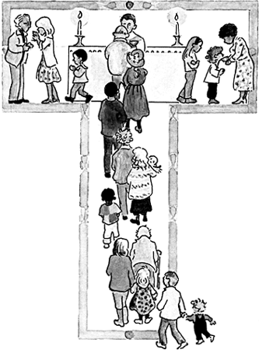

St Edwards Catholic Junior School

Lent Term 2024

God the SAVIOUR~ DIGNITY~ INCARNATION~ Who am I?

TOPIC ~ THEME | ABOUT THE TOPIC | STARTING DATES | Special Feasts
Church  Local Church: Community | Year 3: Journeys  Year 4: Community  Year 5: Mission  Year 6: Sources | 3rd January –  26th January | 7th January; Epiphany of the Lord celebrated in the Church  2nd February: Presentation in the Temple (Candlemas) Y3
Sacrament  Eucharist: Relating | Year 3: Listening & Sharing  Year 4: Giving & Receiving  Year 5: Memorial Sacrifice  Year 6: Unity | 29th January -  1st March  (12th February-  16thFebruary)(Half term) | 11th February: Our Lady of Lourdes  14th February Ash Wednesday (During Half Term)  1st March: St David patron of Wales
Christian Living  Lent/ Easter: Giving | Year 3: Giving all  Year 4: Self-Discipline  Year 5: Sacrifice  Year 6: Death & New Life | 4th March –  28th March  (Maundy Thursday) | 17th March- St Patrick, patron of Ireland  19th March- St Joseph  28th March: Stations of the Cross  Palm Sunday: 24th March  Holy Week: 25th March- 31st March

