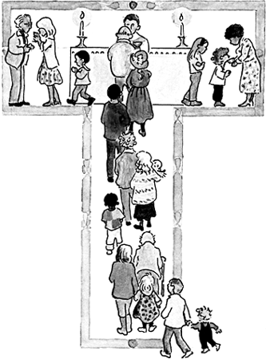

St Edwards Catholic Junior School

Lent Term 2023

God the SAVIOUR~ DIGNITY~ INCARNATION~ Who am I?

TOPIC ~ THEME | ABOUT THE TOPIC | STARTING DATES | Special Feasts
Church  Local Church: Community | Year 3: Journeys  Year 4: Community  Year 5: Mission  Year 6: Sources | 4th January –  27th January | 6th January; Epiphany  2nd February: Presentation in the Temple (Candlemas) Y3 ?
Sacrament  Eucharist: Relating | Year 3: Listening & Sharing  Year 4: Giving & Receiving  Year 5: Memorial Sacrifice  Year 6: Unity | 30th January  (13th February  (Half term)  17th February) –  3rd March | 11th February: Our Lady of Lourdes  1st March: St David patron of Wales  22nd February : Ash Wednesday:  Distribution of Ashes
Christian Living  Lent/ Easter: Giving | Year 3: Giving all  Year 4: Self-Discipline  Year 5: Sacrifice  Year 6: Death & New Life | 6th March –  31st March | 17.03 St Patrick, patron of Ireland  19.03 St Joseph  W/b 27th March: Stations of the Cross with Karl outside tbc  Palm Sunday: 2nd April  Holy Week: 3rd April – 9th April

